Angular Deep Dive

Session 12: in this pic how to use else block of *ngIf in ng-template.

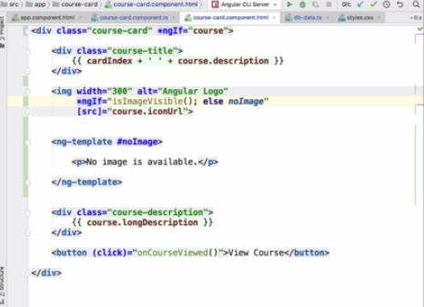

Section 13: Better to use ngClass when we add the styles based on condition and better way ro approach to use declare the method in TS file and return it. In Both pic it’s define how we can return it.  
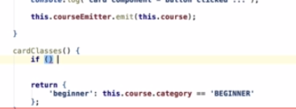



Section 15: how to use ngSwitch.  
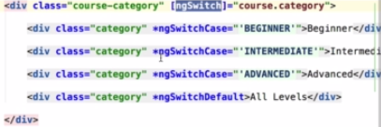

BuiltIn Pipe: **keyValue** which is useful to iterate **object** not an array

employeeName = {  
 name1: ‘’ranjan”,  
 name2: “shayam” };  
<div *ngFor=”let employee of employeeName | keyvalue”>  
 {{employee.key +’ ’+ employee.value}}  
</div>  
  
Builtin pipe **slice** pipe.  
array = [1,2,3,4]  
< div *ngFor = “let arr of array | **slice : 0:2**”>{{arr}}</div>

**Bonous**: To Know more about ng-content, ng-container, ng-trmplate &*ngTemplateOutletOf follow the Below Link.  
<https://www.freecodecamp.org/news/everything-you-need-to-know-about-ng-template-ng-content-ng-container-and-ngtemplateoutlet-4b7b51223691/#:~:targetText=We%20should%20use%20%3Cng%2Dcontainer,template%20dynamically%20into%20a%20page.>

**1 ng-template:**

**These template elements only work in the presence of structural directives.** Angular wrapped up your host <ng-template> within another <ng-template> and converted not only the outer <ng-template> to diagnostic comments but also the inner one! This is why you could not see any of your message.

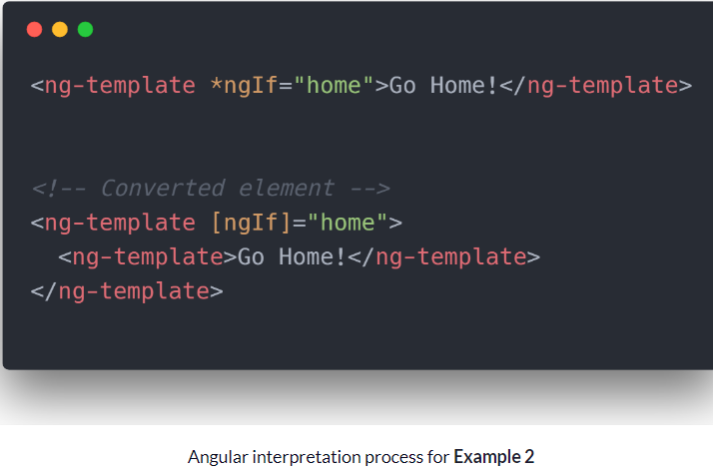

To get rid of this there are two ways to get your desired result: in the given ex. home is a **boolean** value.

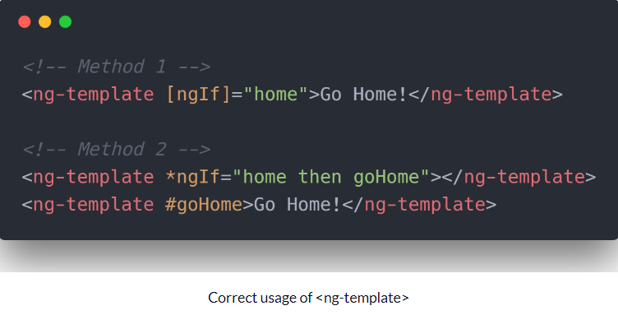

**2 ng-container:**The Angular <ng-container> is a grouping element that doesn't interfere with styles or layout because Angular doesn't put it in the DOM.  
Have you ever written or seen code resembling this:

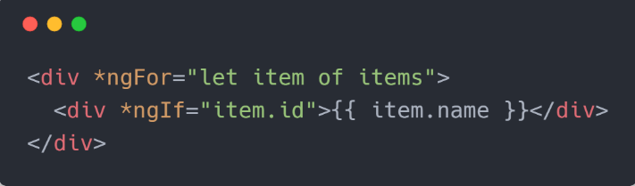

Now this code works fine but it introduces several extra empty <div> in the DOM if item.id is a falsy value which might not be required.

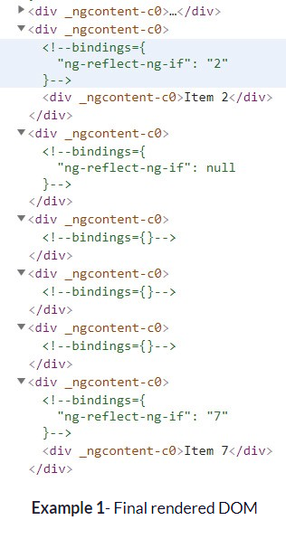

**Let use of ng-container**   
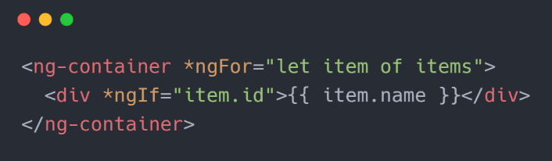

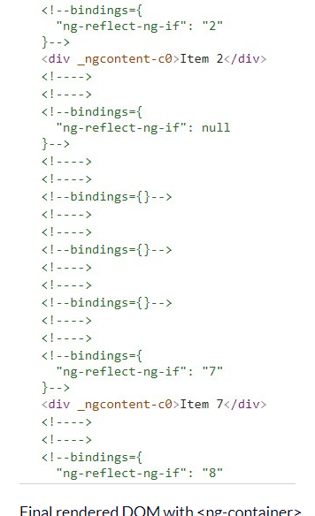

See we got rid of those empty <div>s. We should use <ng-container> when we just want to apply multiple structural directives without introducing any extra element in our DOM.

### 3 ng-content :

They are used to create configurable components. This means the components can be configured depending on the needs of its user.

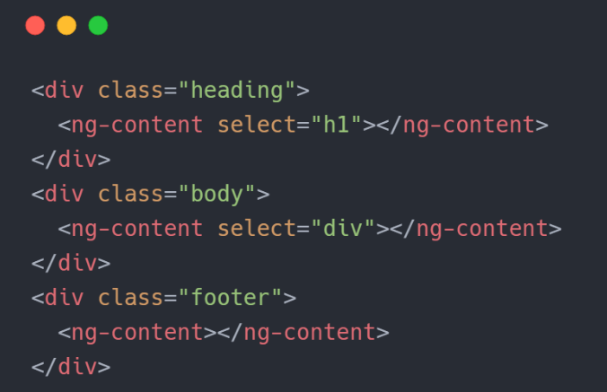

We have modified the <project-content> definition to perform Multi-content projection.The select attribute selects the type of content that will be rendered inside a particular   
<ng-content>. Here we have first select to render header h1 element. If the projected content has no h1 element it won’t render anything. Similarly the second select looks for a div. The rest of the content gets rendered inside the last <ng-content> with no select.

**Calling the component will look like:**

